4th Order Hairpin Bandpass Filter

# Youssef Samwel

# [yo800238@ucf.edu](mailto:yo800238@ucf.edu)

# EEL5437C Microwave Engineering

Prof. Dr. Xun Gong - Section 0012



3.6 GHz, Ripple BW = 0.24 GHz, Fourth Order, Hair Pin Structure, S11 in the ripple bandwidth: < -15 dB

Friday - 11/17/2023

The following is the design Chebyshev table,

Low pass prototype



Saturday 11/18/2023

Goal: bandwidth prototype and begin filter T-line transformation.

[Resonator Tuning]

Initial Resonator Structure

The resonator was initially configured with a total length of λ/2; however, determining the optimal internal coupling to 3.6 GHz necessitated clarification of the appropriate spacing inside the resonator. To address this, I conducted a simulation sweep ranging from 0.1mm to 2mm, with increments of 0.025mm, in order to identify the desired spacing. The following is HFSS simulation of the sweep.

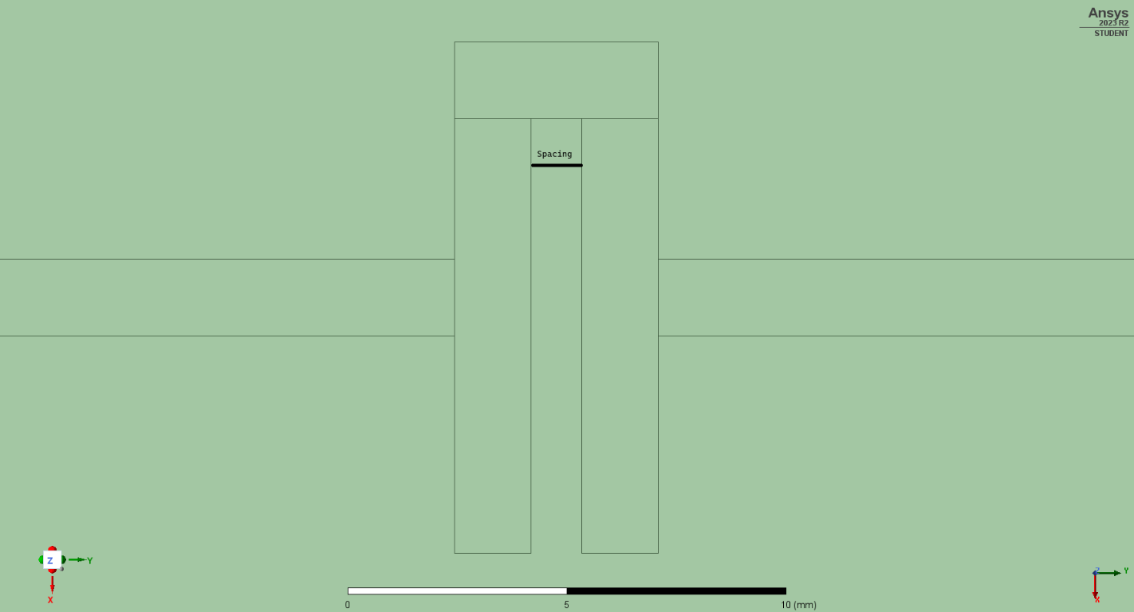To ascertain the optimal spacing length, we can construct the following design chart and interpolate the spacing values accordingly.

Simulation Sweep

|  |  |
| --- | --- |
| Spacing (mm) |  |
| **3.7480** | 3.798 |
| 4.2977 | 3.600 |
| 4.3726 | 3.573 |
| 4.9973 | 3.404 |
| 5.6219 | 3.349 |
| 6.2466 | 3.256 |
| 6.8713 | 3.207 |
| 7.4959 | 3.170 |

Running the simulation using a spacing of 4.2977 mm (0.172) yielded an plot centered at 3.6 GHz.

dB Plot

dB Plot

[Qext synthesis]

offset = 1.8mm

offset = 2.1mm

offset = 2.4mm

offset = 2.7mm

offset = 3mm

|  |  |  |  |  |  |  |  |
| --- | --- | --- | --- | --- | --- | --- | --- |
| **Offset (mm)** |  |  |  |  |  |  |  |
| **1.8000** | 4.007 | -7.44 | 3.92 | -97.44 | 4.091 | 82.56 | 23.43275 |
| 2.1000 | 4.018 | -8.05 | 3.912 | -98.05 | 4.122 | 81.95 | 19.13333 |
| 2.4000 | 4.028 | -6.67 | 3.907 | -96.67 | 4.149 | 83.33 | 16.64463 |
| 2.7000 | 4.012 | 0.07 | 3.871 | -89.93 | 4.15 | 90.07 | 14.37993 |
| 2.8521 | 4.023 | -3.44 | 3.876 | -93.44 | 4.172 | 86.56 | 13.59122 |
| 2.8600 | 4.018 | -0.11 | 3.868 | -90.11 | 4.166 | 89.89 | 13.48322 |
| 3.0000 | 4.023 | 0.24 | 3.863 | -89.76 | 4.182 | 90.24 | 12.61129 |

The desired are computed from Chebyshev table in the following method,

Simulation extrapolation for optimal offset,

[Coupling K simulation]

First HFSS Sweep

